**Background**

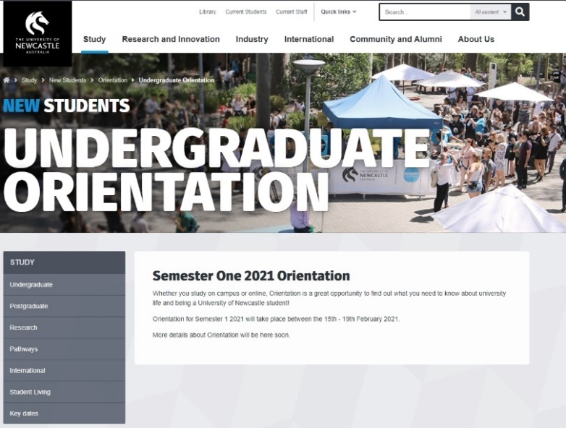For many first-year students, the first semester of university can be a very daunting and nerve-wracking experience. AIS (2019) suggests that anxiety and depression are the two most common reasons that students seek mental health services, according to the Centre for Collegiate Mental Health 2017 Annual Report from Penn State University. Many freshmen have symptoms of anxiety or depression when they first begin higher education with one of the main causes to be a lack of information (Kift, 2014). Students are expected to find supporting information themselves which can be difficult for students who have no one in their social network to help them. It is often the sixth week of the first semester where students finally understand the intricacies of University and by that time, many hardships may have already been experienced. In general, roughly one third of college students either unenroll or transfer by the end of their first year as a result of poor transition into university life (Challen, 2018). University does not have to be this stressful, it can be an encouraging and motivational experience for students to take their first step towards their desired career, as long as students are provided with the right knowledge. The goal of this project will be to address these issues in a place that is accessible for first-year students.

This project is about developing an orientation website designed for first-year students that ease them into university life and will provide services and information that is easily accessible. It will be comprised of knowledge that previous students wished they had known during their first semester. A similar service is present at the University of Technology’s website where a 19-page online orientation document is provided for first-year students that specifically outlines useful information. However, this possesses the same issue with UoN’s orientation webpage being that the information present is too broad for students to pursue specific information and has no links that will take the directly to the source. The webpage will strive to be on accessible platforms for both domestic and international students. The beneficial services provided by the University of Newcastle for first-year students such as key-dates, student living, student ID card info, past student knowledge, FAQ, etc, and will be compiled all into one accessible location.

The University of Newcastle currently offers very broad information on their website that accommodates a wider number of profiles including current students, staff, and pre-university applicants just to name a few. This leaves first year students with little ways to get easy access to relevant information that would let them experience an easy transition into the life at University. There is some information present at UoN’s official website to support first year students, but it requires the students to specifically research into the issue which is difficult if there is ignorance with how the University works. The accessibility of such information is hard to acquire for a first-year student and the information regarding the 2021 student orientation is quite brief and does not provide much useful advice for the start of semester. For example, students beginning university may not how to access the services that UoN provides that will help them during their first semester and the rest of their degree. Such as, borrowing from the library, gaining a public transport concession card, contacting 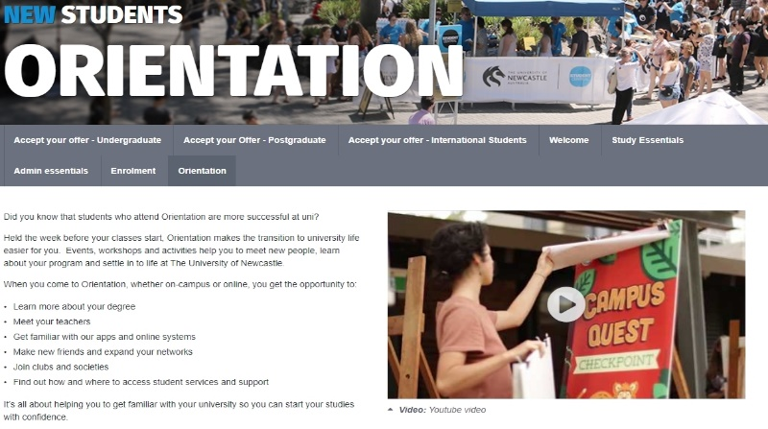mental health services, etc. Many students do no access generic support that was designed to help with the transition process. A study that was done at Melbourne University shows that students show doubt and discomfort when getting help with university anxiety as they deem their problems as not serious enough to warrant action (Harryba, Guilfoyle, Knight, 2012).

The University of Western Sydney’s orientation website is a competitor that has similar features as to what we are implementing with a step by step process of how to transition into university life. This design is very concise; however, this website has information that is too generalised and requires students to have an exact idea of what they are looking for to be of benefit. When planning for this projects webpage UX/UI design, engineers have to keep in mind the user’s ability to get information as quickly and succinctly as possible, while also catering to any disabilities including vision impairment hearing impairment (Petrie, Bevan, 2009). This orientation website for UoN focuses on the user experience without having users to have to specifically know what they are searching for to be as easy to use as possible.

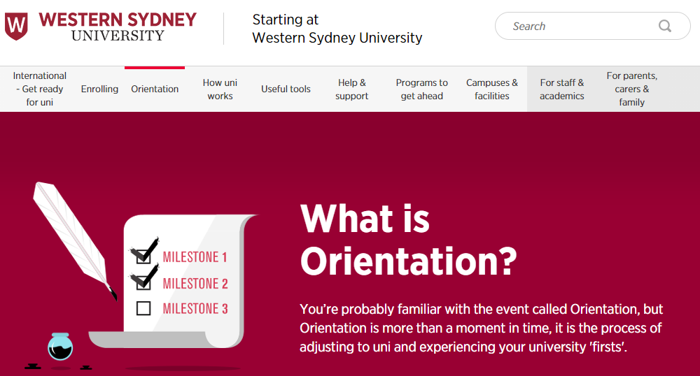

The team will use the traditional waterfall model development method, namely requirements analysis, design, coding, testing, delivery, and regular meetings. Our team members have multiple professional backgrounds such as computer science, system development, and interactive media, which greatly enhances our self-confidence and motivation. The overall goal is to eliminate the stress that comes with transitioning into tertiary schooling for first-year students, and to allow for an enjoyable first impression of the University of Newcastle.

References

<https://www.newcastle.edu.au/>

<https://www.newcastle.edu.au/study/new-students/welcome-to-new/start-smart>

https://www.newcastle.edu.au/study/new-students/orientation/student-feedback-on-orientation

<https://www.westernsydney.edu.au/starting/orientation/what_is_orientation>

https://www.uts.edu.au/sites/default/files/2020-01/ssu-orientation-guide-2020-autumn.pdf

Stefanie Hassel and Nathan Ridout, 2017, “An Investigation of First-Year Students' and Lecturers' Expectations of University Education”, accessed on 5 November 2020, <https://www.ncbi.nlm.nih.gov/pmc/articles/PMC5790796/>

Anne Duffy, 2019, “University student mental health care is at the tipping point”, accessed on 5 November 2020, <https://theconversation.com/university-student-mental-health-care-is-at-the-tipping-point-122743>

Sally Kift, 2014, “Student success: why first year at uni is a make-or-break experience”, accessed on 5 November 2020, <https://theconversation.com/student-success-why-first-year-at-uni-is-a-make-or-break-experience-21465>

Kelly Challen, 2018, “Nearly 1/3 of College Students Drop out or Transfer by the End of Freshman Year: What Can We Do Differently?”, accessed on 5 November 2020, <https://nesca-newton.com/dropoutortransfer/>

Helen L. Petrie and Nigel Bevan, 2009, “The Evaluation of Accessibility, Usability, and User Experience”, accessed on 5 November 2020, https://www.researchgate.net/publication/228538252_The_Evaluation_of_Accessibility_Usability_and_User_Experience

Sophia Harryba, Dr Andrew Guilfoyle and Shirlee-ann Knight, 2012, “Understanding the Challenges of Accessing University Support Services: The Perspectives of Staff Members and International Students”, accessed on 5 November 2020, https://www.researchgate.net/publication/223466479_Understanding_the_Challenges_of_Accessing_University_Support_Services_The_Perspectives_of_Staff_Members_and_International_Students